The forensic laboratory uses a 3D microscope to capture images of fired ammunition components, specifically cartridge cases (as in the images below). These acquired images are then sorted by software for comparison purposes to learn if the cartridges in question came from the same or different firearms, which is information of great value to police investigations.

Masking/colouring is a preparatory function, currently performed manually, which assists the software to identify on the image specific features of interest on the cartridge case. This manual process is tedious and time consuming, and automating it would be a significant improvement.

Please create an algorithm to automatically mask cartridge case images.

Please start with one calibre (for uniformity of primer size) or try a variety to test the method.

Source (Google images) 9mm calibre cartridge cases.

**Image before masking** **Image after masking**

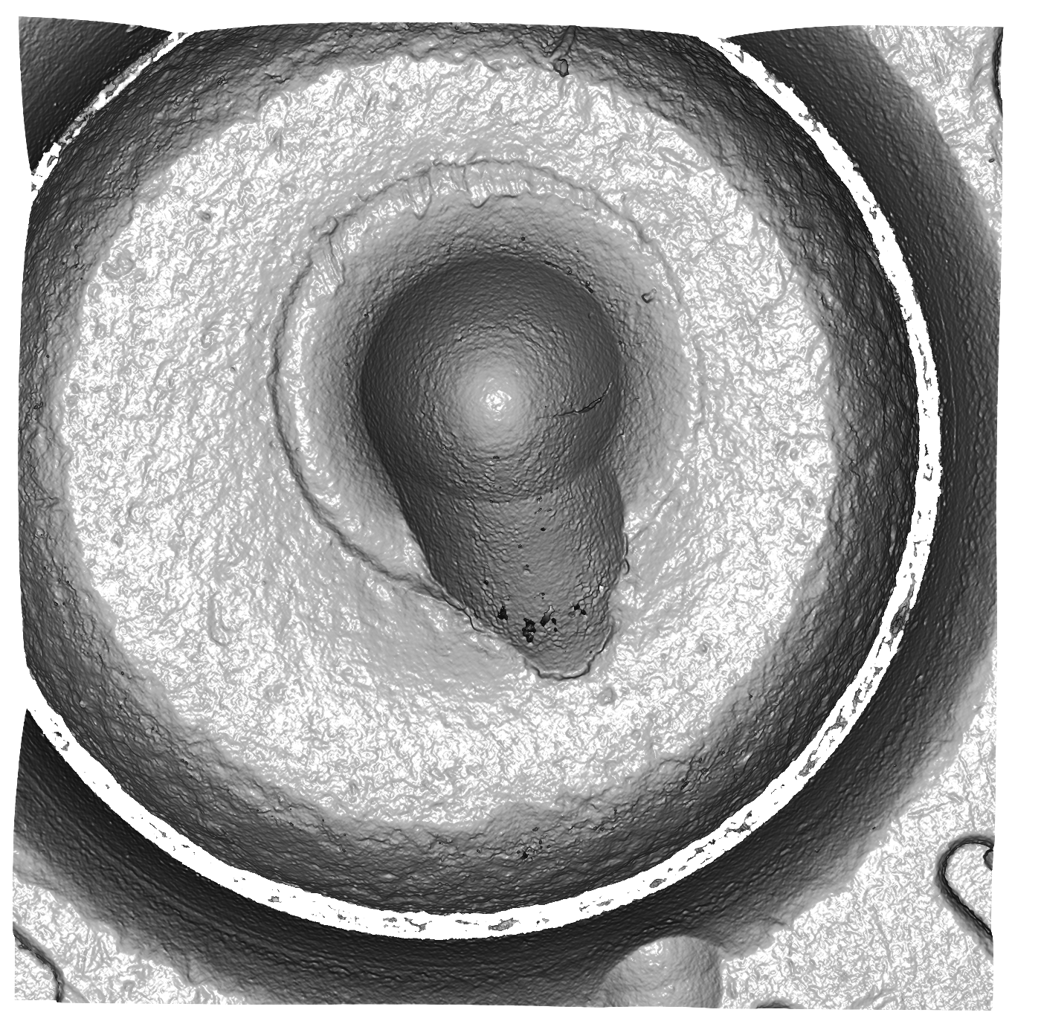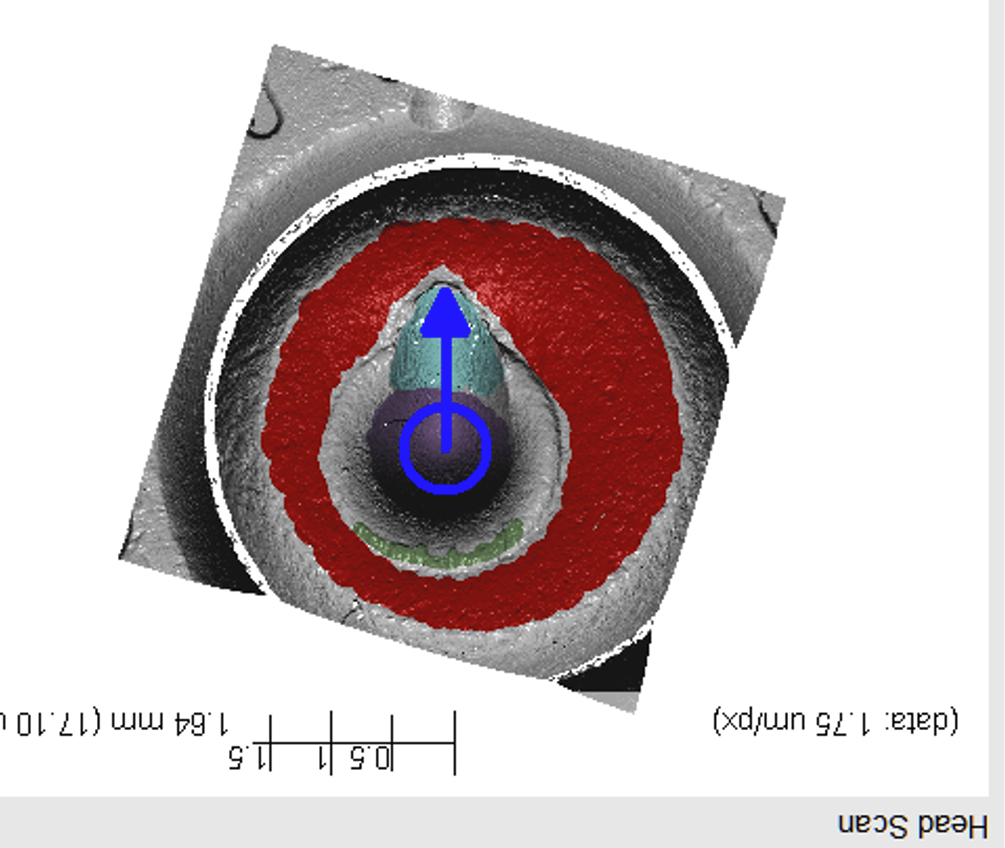

### **Order of masking:**

1. The breech-face impression (red)
2. The aperture shear (green)
3. The firing pin impression (purple)
4. The firing pin drag (light blue)
5. The direction of the firing pin drag (blue arrow)

1

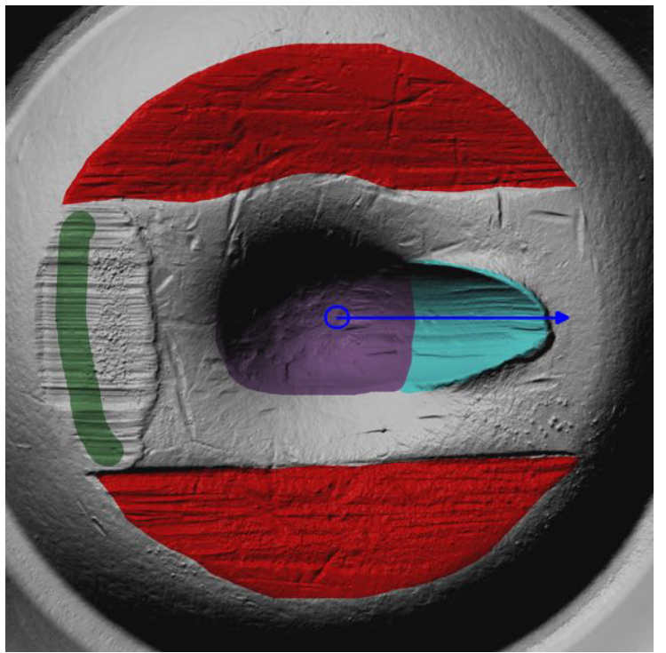

5

4

3

## The requirement for the assignment is to mask, using an algorithm, a single cartridge case image.

Please respond **by 4pm Eastern time on Monday January 22**, with your working package or an accessible link to it.